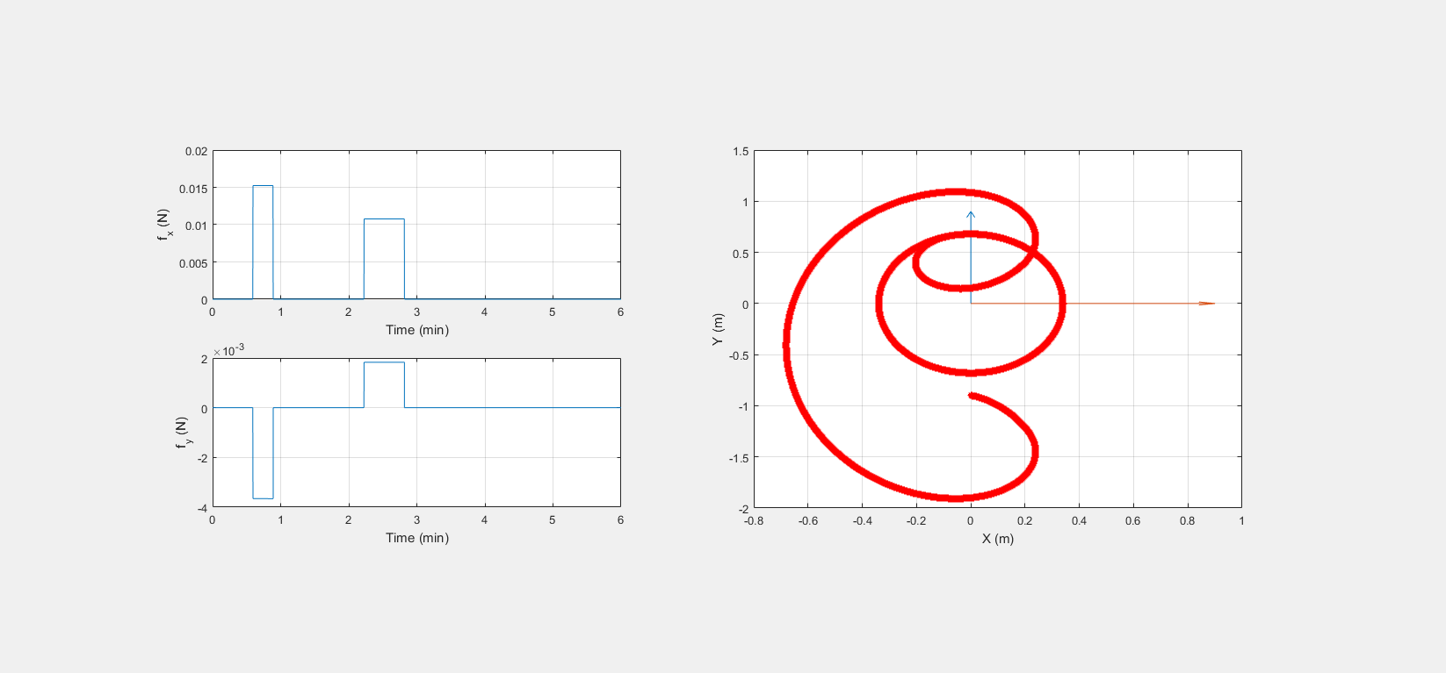

Initial Position

Objective Final Elliptical Orbit Centered Around Chief Satellite

Deputy Satellite Trajectory About Chief Satellite in Chief LVLH

Radial-Tangential Burn Control Profile